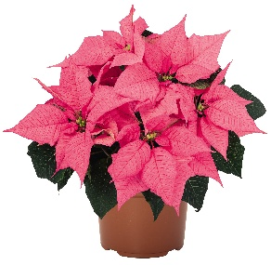
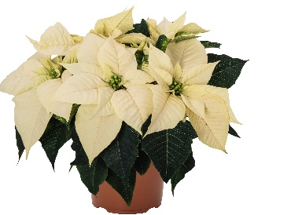
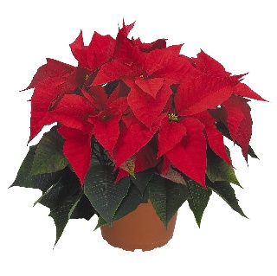
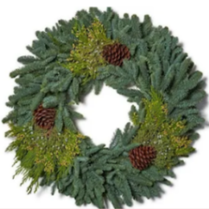

Poinsettias in red, white, and pink, in 6” pots with green foil covers * 23” Noble Fir wreath
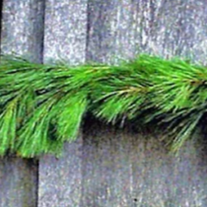
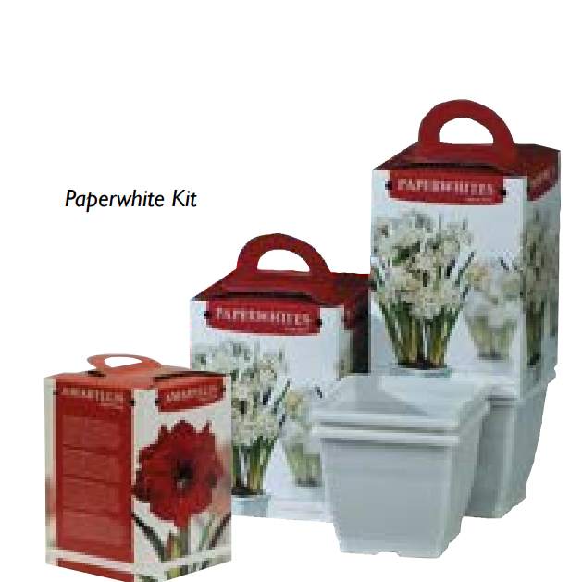
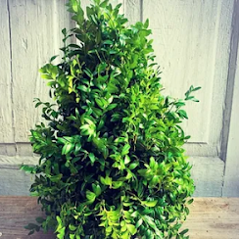

Tree-shaped centerpiece Paperwhites and red Amaryllis kits 25’ Pine garland

Poinsettias & greenery from Pemberton’s Greenhouses, Lexington, KY

Support our fundraiser by placing your ORDER:
NO spay
Ladybug’s (now) adult kitten, feral, dsh, grey tabby, small white stipe on nose, may have tipped ear, spayed
Name ___________________________________
Prices:
Poinsettias ________
25’ Pine garland ________
Fir wreath 23” _________
Tree centerpiece 19” _____
Paperwhites kit________
Amaryllis kit_____

Address _________________________________
Phone __________________________________

Quantity:
Poinsettias: red______ pink______ white ______
25’ pine garland______ 23” Wreath _______ Paperwhites kit_______
Boxwood tree-shaped centerpiece_______ Red Amaryllis kit_________
TOTAL $________

Please return this form to: ___________________________________________________________
___________________________ Thank you for supporting our fundraiser!
*Poinsettias come with green foil pot covers

